Autonomous Mobile Robots Challenge
(Option 1)
Embedded Systems Project
Princess Sumaya University for Technology
Faculty of Engineering

Project Team Members:
Jenahn Al Mosrati 20220796
Leedia Al Safadi 20210836
Ban Alsaket 20220607
Instructor:
Dr.Esam Qaralleh
Date:
14/1/2026

Table of Contents
Abstract 2
1. Introduction and Background 2
2. System Design 3
2.1 Mechanical Design 3
2.2 Electrical Design 4
2.3 Software Design 4
3. Problems and Recommendations 4
4. Conclusion 5
5. References 5

Abstract
This project presents the design and implementation of an autonomous mobile robot based on the PIC16F877A microcontroller. The robot is capable of line following, obstacle detection, and tunnel detection using a combination of infrared (IR) sensors, an ultrasonic sensor, and a light-dependent resistor (LDR). Motor control is achieved using Pulse Width Modulation (PWM) signals and an H-bridge motor driver. A buzzer is activated when the robot enters a dark tunnel. The robot successfully demonstrates autonomous navigation by following a predefined path, avoiding obstacles, and responding to environmental lighting conditions.

1. Introduction and Background
Autonomous mobile robots are widely used in industrial automation, surveillance, and intelligent transportation systems. These robots rely on sensors and embedded controllers to perceive their environment and make decisions without human intervention.
The objective of this project is to design and implement an autonomous mobile robot that fulfills the requirements of the Autonomous Mobile Robots Challenge. The robot must follow a black line, detect obstacles, and respond to dark tunnel conditions using embedded system techniques.

2. System Design

2.1 Mechanical Design
The robot is built on a two-wheel differential drive chassis. Two DC motors are mounted on the left and right sides of the chassis to provide forward movement and turning capability. A caster wheel is used for balance. The mechanical design ensures stability and smooth movement during operation.
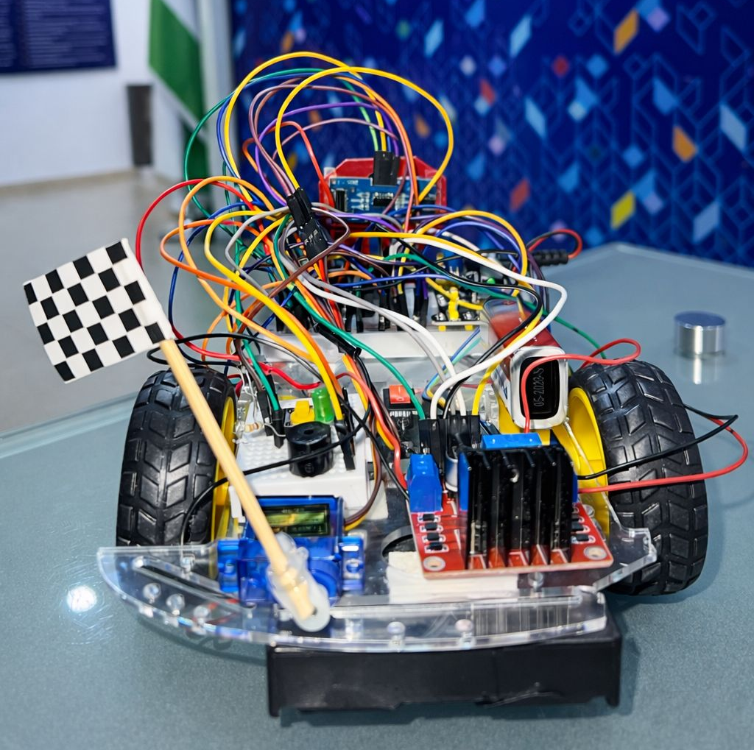
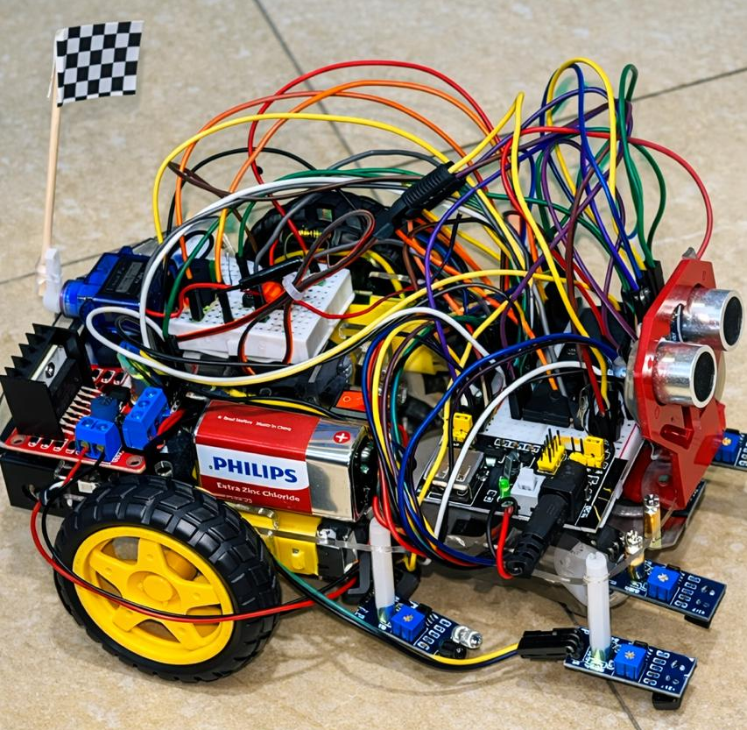
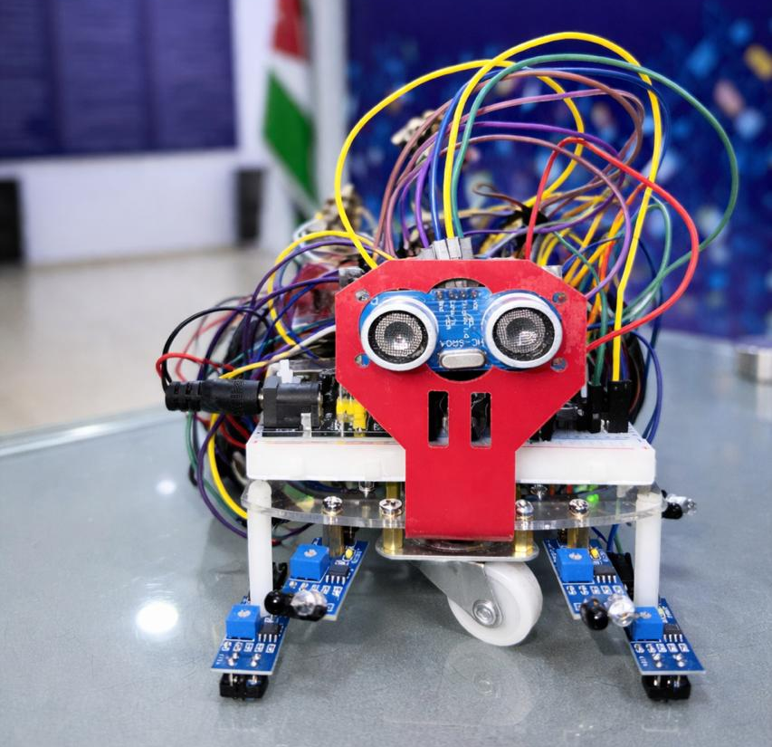
  - Figure 1: Side of Robot Car Figure 2: Rear of Robot Car
  - Figure 3: Front of Robot Car

2.2 Electrical Design
The electrical system is centered around the PIC16F877A microcontroller, which controls all robot operations. An H-bridge motor driver is used to control the DC motors using PWM signals. Infrared sensors connected to RD2 and RD3 are used for line detection. An ultrasonic sensor with its trigger connected to RD7 and echo to RD6 is used for obstacle detection. An LDR connected to RA0 is used for tunnel detection, while a buzzer connected to RD5 provides an audible alert in dark conditions. Rechargeable batteries supply power to the system.
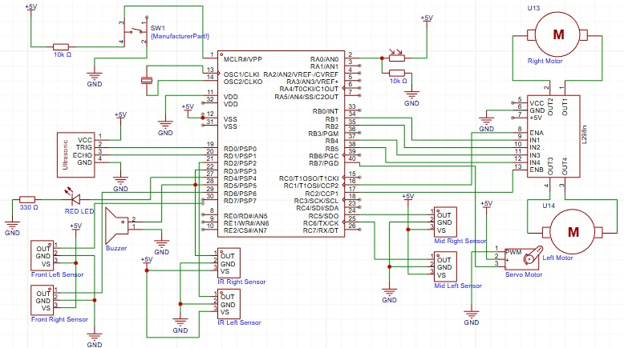
  - Figure 4: Hardware Schematic Design

2.3 Software Design
The software is developed using mikroC PRO for PIC and follows a modular structure. The program initializes all peripherals, including ports, ADC, and PWM modules. The robot continuously reads the IR sensors to follow the line, checks the LDR value to detect dark tunnels, and uses the ultrasonic sensor to detect obstacles. When an obstacle is detected, the robot stops briefly, turns right, and then continues moving forward. This approach ensures reliable autonomous operation.
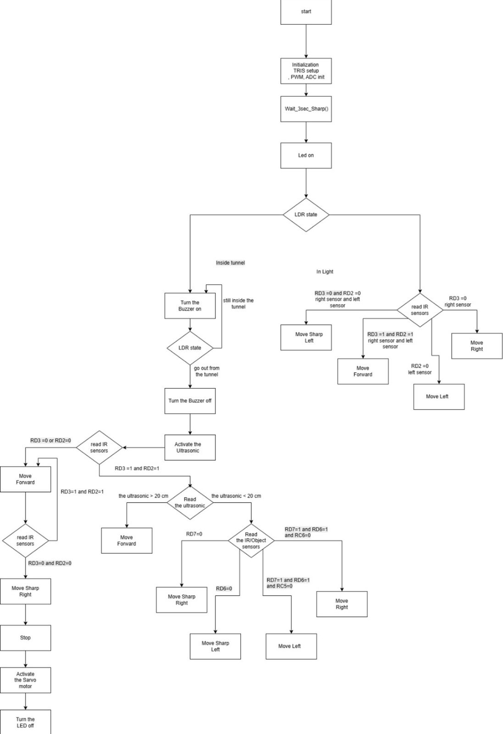
  - Figure 5: Flowchart Diagram

2.4 Required Links
Embedded Poster pdf:
Embedded_System poster (4) (1).pdf
Youtube Link:
https://youtube.com/shorts/vIPrB1ooe1Y?feature=share
Code link:
MyProject.zip

3. Problems and Recommendations

During the development and testing phases of the project, several practical challenges were encountered that significantly affected progress and required repeated troubleshooting. One of the major issues was the accidental burning of electronic components, including the microcontroller and parts of the power circuitry. Detecting the damaged components took a long time, as the fault was not always visually apparent, which led to extended debugging sessions and delays in development.

Another recurring problem occurred during software integration. In multiple instances, adding new sections of code caused the entire system to malfunction, even though the existing code was previously working correctly. This made debugging more complex, as the issue was not always isolated to a single module and required repeated testing and restructuring of the code.

Hardware-related issues were also frequent. Loose wires, faulty connections, and breadboard failures caused intermittent or complete system shutdowns. In some cases, a single damaged wire or breadboard connection prevented the robot from operating, and identifying the exact source of the problem was time-consuming. On one occasion, the breadboard itself was damaged, which forced a complete rewiring of the entire system from scratch to restore functionality.

These challenges highlighted the importance of careful hardware handling, systematic debugging, and gradual software integration. It is recommended to test components individually before full integration, use high-quality breadboards and wiring, and document all wiring connections to simplify reconstruction if failures occur. Additionally, implementing incremental code testing and maintaining backup versions of working code can greatly reduce debugging time and improve system reliability.

إ 4. Conclusion
This project successfully demonstrates the design and implementation of an autonomous mobile robot using the PIC16F877A microcontroller. The robot is capable of line following, obstacle avoidance, and tunnel detection. The project provided practical experience in embedded systems design, sensor integration, and motor control, and it met all the objectives of the Autonomous Mobile Robots Challenge.

5. References
[1] PIC16F877A Datasheet – Microchip Technology
[2] mikroC PRO for PIC Documentation
[3] HC-SR04 Ultrasonic Sensor Datasheet

